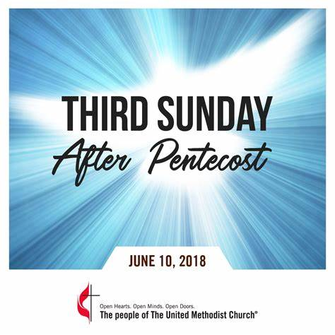**Third Sunday after Pentecost**

*St. Mary’s Episcopal Church*

*Palmetto, Florida*

**Parish Staff**

**The Rev. Cheri Ford, Priest** [revcheri.stmaryspalmetto@gmail.com](mailto:revcheri.stmaryspalmetto@gmail.com) (906) 450-5718

**The Rev. William de la Torre, Hispanic Ministry (**813) 802-8617

**Music Minister: Joyce Ives** (603) 236-1939

**Admin. Asst. Tina Clemen** [stmaryspalmetto@verizon.net](mailto:stmaryspalmetto@verizon.net) (941) 722-5292

**ST. MARY’S VESTRY**

**Senior Warden – Frank Grondahl** [ffgskg@msn.com](mailto:ffgskg@msn.com) **(**941) 212-8219

**Junior Warden** **– Bill Cooley** [dcool12839@gmail.com](mailto:dcool12839@gmail.com) (518) 796-2352, (518) 791-2774

**Treasurer**- **Lorraine Wood** [ljhwood53@gmail.com](mailto:ljhwood53@gmail.com) (941) 447-3570

**Beverly Hunt** [Huntb104@gmail.com](mailto:Huntb104@gmail.com) (941) 228-1888

**Nancy Valenti** [nancyval@hotmail.com](mailto:nancyval@hotmail.com) (941) 729-1824

**Peggy Brogan** [pegbrogan48@gmail.com](mailto:pegbrogan48@gmail.com) **(**941) 744-6429

**Sue Cowhig** [jscowhig@sbcglobal.net](mailto:jscowhig@sbcglobal.net) (707) 980-3056

**Holly Quillian** [hollyqsaks@outlook.com](mailto:hollyqsaks@outlook.com) (941) 518-9762

All music printed in bulletin is under One License.net

**Third Sunday After Pentecost**

June 29, 2025

St. Mary’s Episcopal Church

Palmetto, Florida

**Prelude:** “Two Fishermen” … Susanne Toolan. Chancel Choir

**Processional:** #525 “the Church’s one foundation

Celebrant Blessed be God: Father, Son, and Holy Spirit.

People **And blessed be his kingdom, now and for ever. Amen**

**The Gloria BCP 356 S-280**

Glory to God in the highest,

 and peace to his people on earth.

Lord God, heavenly King,

almighty God and Father,

 we worship you, we give you thanks,

 we praise you for your glory.

Lord Jesus Christ, only Son of the Father,

Lord God, Lamb of God,

you take away the sin of the world:

 have mercy on us;

you are seated at the right hand of the Father:

 receive our prayer.

For you alone are the Holy One,

you alone are the Lord,

you alone are the Most High, Jesus Christ,

 with the Holy Spirit,

 in the glory of God the Father. Amen.

**The Collect of the Day**

*The Celebrant says to the people*

The Lord be with you.

People **And also with you.**

Celebrant Let us pray.

Almighty God, you have built your Church upon the foundation of the apostles and prophets, Jesus Christ himself being the chief cornerstone: Grant us so to be joined together in unity of spirit by their teaching, that we may be made a holy temple acceptable to you; through Jesus Christ our Lord, who lives and reigns with you and the Holy Spirit, one God, for ever and ever. Amen.

**The Lessons**

**2 Kings 2:1-2 6-14**

The Word of the Lord.

People **Thanks be to God.**

**Psalm 77:1-2, 11-20 – Please respond after the (*) asterisk**

1I will cry aloud to God; *  
I will cry aloud, and he will hear me.

2 In the day of my trouble I sought the Lord; *  
***my hands were stretched out by night and did not tire; I refused to be comforted.***

11 I will remember the works of the Lord, *  
***and call to mind your wonders of old time.***

12 I will meditate on all your acts *  
***and ponder your mighty deeds.***

13 Your way, O God, is holy; *  
***who is so great a god as our God?***

14 You are the God who works wonders *  
***and have declared your power among the peoples.***

15 By your strength you have redeemed your people, *  
***the children of Jacob and Joseph.***

16 The waters saw you, O God; the waters saw you and trembled; *  
***the very depths were shaken.***

17 The clouds poured out water; the skies thundered; *  
***your arrows flashed to and fro;***

18 The sound of your thunder was in the whirlwind; your lightnings lit up the world; *  
***the earth trembled and shook.***

19 Your way was in the sea, and your paths in the great waters, *  
***yet your footsteps were not seen.***

20 You led your people like a flock *  
***by the hand of Moses and Aaron.***

**Galatians 5:1, 13-25**

The Word of the Lord.

People **Thanks be to God.**

**Gradual**: Insert **“Jesus calls us; o’er the tumult” vs 1 & 2**

The Holy Gospel of our Lord Jesus Christ according to Luke.

People **Glory to you, Lord Christ.**

**Luke 9:51-62**

The Gospel of the Lord.

People **Praise to you, Lord Christ.**

**Gradual**: Insert **“Jesus calls us; o’er the tumult” vs 3 & 4**

**The Homily– The Rev. Dr. Lisa Barrowclough**

**The Nicene Creed** - *Pg. 358.*

**Prayers of the People –** *The leader and People pray responsively.*

Father, we pray for your holy Catholic Church;

***That we all may be one.***

Grant that every member of the Church may truly and humbly serve you;

***That your Name may be glorified by all people.***

We pray for all bishops, priests, and deacons;

***That they may be faithful ministers of your Word and Sacraments.***

We pray for all who govern and hold authority in the nations of the world;

***That there may be justice and peace on the earth.***

Give us grace to do your will in all that we undertake;

***That our works may find favor in your sight.***

Have compassion on those who suffer from any grief or trouble;

***That they may be delivered from their distress.***

Give to the departed eternal rest;

***Let light perpetual shine upon them.***

We praise you for your saints who have entered into joy;

***May we also come to share in your heavenly kingdom.***

Let us pray for our own needs and those of others.

*The people may add their own petitions.*

*The Celebrant adds a concluding Collect.*

**The Peace**

The peace of the Lord be always with you.

People **And also with you.**

**Birthdays and Anniversaries**

**ANNOUNCEMENTS**

**Offertory**

**Offertory hymn**: Levas #136 **“I have decided to follow Jesus.”**

**Eucharistic Prayer – A** Page 361

The Lord be with you.

**People And also with you.**

Lift up your hearts.

People **We lift them to the Lord.**

Let us give thanks to the Lord our God.

People **It is right to give him thanks and praise.**

Celebrant It is right, and a good and joyful thing, always and everywhere to give thanks to you, Father Almighty, Creator of heaven and earth.

Therefore we praise you, joining voices with Angles and Archangels and with all the company of heaven, who for ever sing this hymn to proclaim the glory of your name.

**Sanctus BCP #371** music **S-129**

*Celebrant and People.*

**Holy, Holy, Holy Lord, God of power and might,**

**heaven and earth are full of your glory.**

**Hosanna in the highest.**

**Blessed is he who comes in the name of the Lord.**

**Hosanna in the highest.**

*The Celebrant continues*

Holy and gracious Father: in your infinite love you made us for yourself; and, when we had fallen into sin and become subject to evil and death, you, in your mercy, sent Jesus Christ, your only and eternal son, to share our human nature, to live and die as one of us, to reconcile us to you, the God and Father of all.

He stretched out his arms upon the cross, and offered himself in obedience to your will, a perfect sacrifice for the whole world.

On the night he was handed over to suffering and death, our Lord Jesus Christ took bread; and when he had given thanks to you, he broke it, and gave it to his disciples, and said, “Take, eat: This is my Body, which is given for you. Do this for the remembrance of me.”

After supper he took the cup of wine; and when he had given thanks, he gave it to them and said, “Drink this, all of you: This is my Blood of the new Covenant, which is shed for you and for many for the forgiveness of sins. Whenever you drink it, do this for the remembrance of me.”

Therefore we proclaim the mystery of faith:

*Celebrant and People*

Christ has died.

Christ is risen.

Christ will come again.

*The Celebrant continues*

We celebrate the memorial of our redemption, O Father, in this sacrifice of praise and thanksgiving. Recalling his death, resurrection, and ascension, we offer you these gifts.

Sanctify them by your Holy Spirit to be for your people the Body and Blood of your Son, the holy food and drink of new and unending life in him. Sanctify us also that we may faithfully receive this holy Sacrament, and serve you in unity, constancy, and peace; and at the last day bring us with all your saints into the joy of your eternal kingdom.

All this we ask through your Son Jesus Christ. By him, and with him, and in him, in the unity of the Holy Spirit all honor and glory is yours, Almighty Father, now and for ever. Amen

And now, as our Savior Christ has taught us, we are bold to say,

**The Lord’s Prayer (said)**

**The Breaking of the Bread**

Christ our Passover is sacrificed for us;

**Therefore let us keep the feast.**

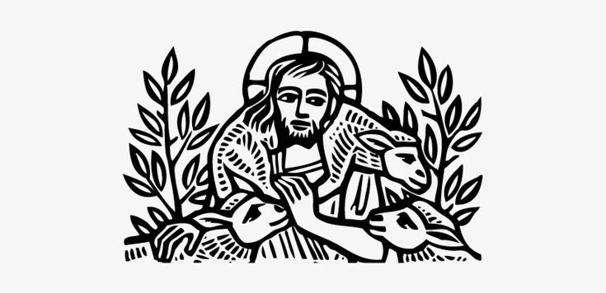**The Invitation**

**Communion Hymn:** #490 **“I want to walk as a child of light”**

The Body of Christ, the bread of heaven. [Amen.]

The Blood of Christ, the cup of salvation. [Amen.]

**The Prayer of Thanksgiving** (Page 365)

**The Blessing**

**Recessional Hymn**: #559 **“Lead us, heavenly Father, lead us“**

Go in Peace, to Love and Serve the Lord.

**Thanks be to God.**

**Postlude: “Rondeau” … Henry Purcell**

**Prayer of Healing and Wellness:**

***Parishioners:***The Bustle’s, Kathryn Stevenson, Karen Moore, Priscilla Martin, Marilyn Wolter, Jodey Porter, Bill Gill, Bill Speer, Lynda Priepot, Steve Ives, Barbara Renney, Mary Jane Daggett, Ora Mae James and Fr. Glen.

***Family and Friends:*** Brand Ramsey (family friend of The Reynolds), Charlotte (daughter of Holly Quillian), Robert Johnson (son of Lynda Priepot), Betsy Ramsey and Mary and Jack Hertenstein (friends of The Reynolds), Dick Stagner (brother in law of Louise Silvanic), Steve Gillespie (nephew of Gail Cascella), Nicola Moxey (daughter of Christine Pratley), Taryon Degon (granddaughter of Jan Ciancarelli), Carol Johnson’s sister, Christine Booth (Fr. Glen’s sister), Karen Perdue (Gail Cascella’s niece), Kevin-Ford family (family of The Ford’s), Paul Ciancarelli (Jan’s son), Art Sounia (friend of Doreen Colket) and Juliet Clarke (granddaughter of Pratley’s), Joe Fairchild (friend of the Cooley’s), Melanie Moran (friend of Christine) and Emily Ann Norris (family of Linney Reynolds), Marge Schrauth (friend of Fr. Glen), Dan Bryan (brother-in-law of Bob Cabnet), Maxwell Kappel (grandson of The Martin’s), Maxon McNeil (friend of the Shorts), Jayme and Jeremy (family of Cooley’s), and Kathy Harlow (sister of Doreen Colket), John Heath (friend of Jane Bryant), Ron Bernot (Neighbor of Dinny Sayre), Jordan Skeard (nephew of Alice and George Short), Rev. Jane Allen (Short’s priest in Newfoundland), Elleh Kearley (sister of George and Alice Short), George Silvanic (Louise’s grandson), Wally Skeard (brother in law to George & Alice Short), Wall, Elisa Hughes, Dr. Greg Gutowski (Priscilla Martin), Steve Harlow (brother-in-law of Doreen Colket), Karen Fitzgerald (cousin of Doreen Colket), Joe Ladika (friend of Bev Hunt), Dan Burkhart (neighbor of George & Alice Short), Evelyn Smith and daughter Michelle (friends of George & Alice Short), Leo Uribe (dear friend of The Reynolds), The Pruiksmas (friends of the Cooley’s), Dallas Eugene (Gene) Jarvis (friends George & Alice Short)

***Prayers for Safety and Service****:*

Ben Richardson (son of Christine Pratley), Alexander Moxey (grandson of Christine), George Phillip Silvanic (Louise Silvanic’s grandson), Jody Cooley (son of Bill and Donna Cooley), and Logan Valenti (grandson of Nancy Valenti).



St. Mary’s Episcopal Church

1010 24th Ave West. Palmetto, FL

941 722-5292



|  |  |  |  |  |  |  |
| --- | --- | --- | --- | --- | --- | --- |
| Sun | Mon | Tues | Wed | Thurs | Fri | Sat |
| 29-Jun | 30-Jun | 01-Jul | 02-Jul | 03-Jul | 04-Ju | 05-Jul |
| Worship Svc  English:  08 & 10am  Hispanic: 12 pm |  | Food Pantry  9:00 – 11:00am |  |  | **Happy Independence Day!** |  |
| 06-Jul | 07-Jul | 08-Jul | 09-Jul | 10-jul | 11-Jul | 12-Jul |
| Worship Svc  English:  08 & 10am  Hispanic: 12 pm |  | Food Pantry  9:00 – 11:00am | Prayer & Bible Study 0930am |  |  |  |

|  |
| --- |
| 4th of July Fireworks on the Manatee River 9:30pm-10:00pm |
| 09 Jul – Prayer & Bible Study 9:30am |



|  |  |
| --- | --- |
| !! Happy Birthday !! | |
| 29 Jun | Lynda Priepot |
| 11 Jul | Larry Bustle |
| 🎔 Happy Anniversary 🎔 | |
| 15 Jul | Sue & Jimmy Cowhig |
|  |  |

**We will be updating the Parish Directory soon.**

**Stay tuned for more information!**