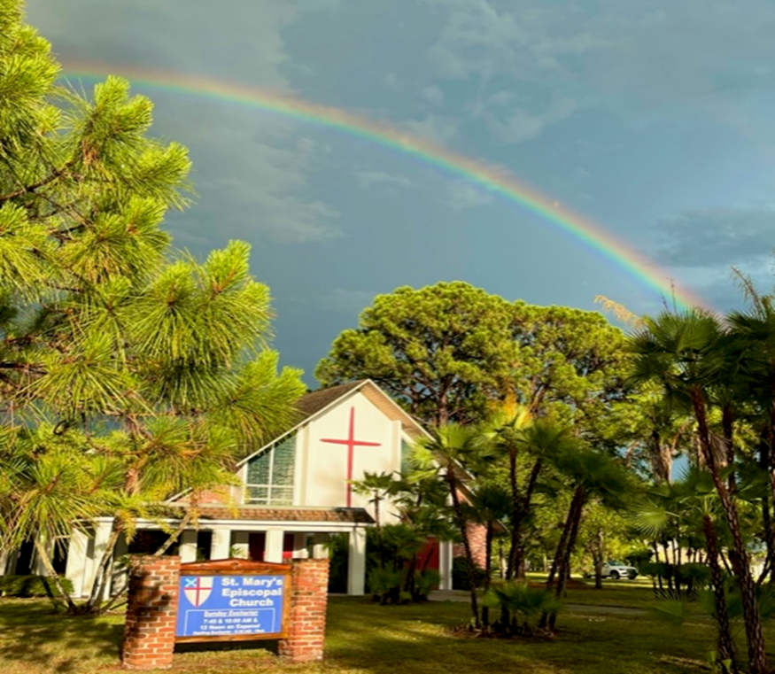

**Photo by Susan Hunt**

1010 24th Avenue West, Palmetto, FL 34221

941-722-5292

Email – [stmaryspalmetto@verizon.net](mailto:stmaryspalmetto@verizon.net)

Website – stmaryspalmetto.com

**Pentecost 20**

**October 6, 2024**

**PARISH STAFF**

**The Rev. Glen Graczyk, Rector** [frgleng@gmail.com](mailto:frgleng@gmail.com) (727) 432-4014

**The Rev. William de la Torre, Hispanic Ministry (**813) 802-8617

**Rev. Cheri Ford, Assisting Priest** (941) 981-3195)

**Music Minister: Joyce Ives** (603) 236-1939

**Admin. Asst. Elisa Hughes** [stmaryspalmetto@verizon.net](mailto:stmaryspalmetto@verizon.net) (813) 394-0032

**ST. MARY’S VESTRY**

**Senior Warden – Frank Grondahl** [ffgskg@msn.com](mailto:ffgskg@msn.com) **(**941) 900-1009

**Junior Warden** **– Bill Cooley** [dcool12839@gmail.com](mailto:dcool12839@gmail.com) (518) 796-2352, (518) 791-2774

**Treasurer**- **Lorraine Wood** [ljhwood53@gmail.com](mailto:ljhwood53@gmail.com) (941) 447-3570

**Beverly Hunt** [Huntb104@gmail.com](mailto:Huntb104@gmail.com) (941) 228-1888

**Nancy Valenti** [nancyval@hotmail.com](mailto:nancyval@hotmail.com) (941) 729-1824

**Peggy Brogan** [pegbrogan48@gmail.com](mailto:pegbrogan48@gmail.com) **(**941) 744-6429

**Lynda Priepot** [lyndajpriepot@yahoo.com](mailto:lyndajpriepot@yahoo.com) (941) 504-2505

All music printed in bulletin is under One Lic

**10:00 - Prelude: *Jesus Loves Me*** (based on Clair de Lune) William Bradbury/Claude DeBursy

Arr. Fred Boch

**10:00 - Call to Worship: *This is the day****…Les Garrett*

*This is the day, this is the day that the Lord has made, that the Lord has made.*

*We will rejoice, we will rejoice and be glad in it and be glad in it.*

*This is the day that the Lord has made, we will rejoice and be glad in it.*

*This is the day; this is the day that the Lord has made*

**10:00 - Processional Hymn: *All hail the power of Jesus’ Name*** - #450 vs. 1,2,3 & 6

**Greeting:**

**C:** Blessed be God: Father, Son, and Holy Spirit.

**P:** And blessed be his reign, now and forever. Amen

**Hymn of Praise:** ***The Gloria***

**7:45 -**– Page 356 **BCP**

**10:00** – **Gloria** – White music insert

**Collect of the day:**

Almighty and everlasting God, you are always more ready to hear than we to pray, and to give more than we either desire or deserve: Pour upon us the abundance of your mercy, forgiving us those things of which our conscience is afraid, and giving us those good things for which we are not worthy to ask, except through the merits and mediation of Jesus Christ our Savior; who lives and reigns with you and the Holy Spirit, one God, for ever and ever

**P**: Amen

**The Lessons**

*Sit*

**First Reading: *Genesis 2:18-24***

**R:** The Word of the Lord.

***P:***  *Thanks be to God.*

**Psalm Response:** ***Psalm 8***

|  |
| --- |
| O LORD our Governor, *     how exalted is your Name in all the world! |
| Out of the mouths of infants and children *     your majesty is praised above the heavens. |
| You have set up a stronghold against your adversaries, *     to quell the enemy and the avenger. |
| When I consider your heavens, the work of your fingers, *     the moon and the stars you have set in their courses, |
| What is man that you should be mindful of him? *     the son of man that you should seek him out? |
| You have made him but little lower than the angels; *     you adorn him with glory and honor; |
| You give him mastery over the works of your hands; *     you put all things under his feet: |
| All sheep and oxen, *     even the wild beasts of the field, |
| The birds of the air, the fish of the sea, *     and whatsoever walks in the paths of the sea. |
| O LORD our Governor, *     how exalted is your Name in all the world! |

**Second Reading: *Hebrews 1:1-4, 2:5-12***

**R:** The Word of the Lord.

***P:*** *Thanks be to God.*

*Stand*

**10:00 - Gospel Hymn: *Lead us, heavenly Father, lead us*** - #559 vs.1 & 2

**C:**  My sisters and brothers a reading from the Holy Gospel of our Lord Jesus Christ according to Mark.

***P:***  *Glory to you, Lord Christ*

**Gospel: *Mark 10:2-16***

**C**: The Gospel of the Lord.

***P:*** *Praise to you Lord, Christ.*

**10:00 - Gospel Hymn:** #559 vs. 3

*Sit*

***Homily****:*

*Stand*

**Profession of Faith:*****Nicene Creed*** – Page 358 **BCP**

**Prayers of the People**:*God ever mindful of us, hear our prayer.*

**Confession of Sin:** Page 360 **BCP**

**Peace**

*Sit*

**Announcements:**

**Offertory Sentence:** Offer to God a sacrifice of thanksgiving and make good thy vows unto the Most High. Psalm 50:14

**Offertory Hymn: *Love divine, all loves excelling*** - #657

**THE GREAT THANKSGIVING**

*Stand*

**Preface of the Lord’s Day**

**Sanctus: 7:45 *–*** P. 363 ***– BCP***

**10:00 *–*** ***Sanctus –*** *White music insert*

**Eucharistic Prayer C –** P. 369 **BCP** – Congregation responds with *italicized phrases*

**Great Amen -**

**The Lord’s Prayer:***Our Father . . .*

**Breaking of the Bread:**

**C:** Alleluia!Christ our Passover is sacrificed for us;  
***P:****Therefore, let us keep the feast. Alleluia!*

**Prayer for a Spiritual Communion:**

My Jesus, I believe that you are truly present in the Blessed Sacrament of the Altar. I love you above all things, and long for you in my soul. Since I cannot receive you in the Sacrament of your Body and Blood, come spiritually into my heart. Cleanse and strengthen me with your grace, Lord Jesus, and let me never be separated from you. May I live in you, and you in me, in this life and in the life to come. Amen.

**Communion Hymn: *Make me a channel of your peace*** *–* Grey music insert

*Stand*

**Prayer after Communion:** Page 365 ***BCP***

**Blessing:**

**Recessional Hymn: *Canticle of the sun*** – Grey music insert – Refrain, Verses 1-6 - Refrain

**Dismissal:**

**Prayer of Healing and Wellness:**

***Parishioners:***The Bustle’s, Kathryn Stevenson, Karen Moore, Priscilla Martin, Marilyn Wolter, Jodey Porter, Bill Gill, Bill Speer, Louise Silvanic, Lynda Priepot, Steve Ives, Barbara Renney, Mary Jane Daggett, Ora Mae James and Fr. Glen.

***Family and Friends:*** Brand Ramsey (family friend of The Reynolds), Charlotte (daughter of Holly Quillian), Robert Johnson (son of Lynda Priepot), Betsy Ramsey and Mary and Jack Hertenstein (friends of The Reynolds), Dick Stagner (brother in law of Louise Silvanic), Steve Gillespie (nephew of Gail Cascella), Nicola Moxey (daughter of Christine Pratley), Taryon Degon (granddaughter of Jan Ciancarelli), Carol Johnson’s sister, Christine Booth (Fr. Glen’s sister), Karen Perdue (Gail Cascella’s niece), Kevin-Ford family (family of The Ford’s), Paul Ciancarelli (Jan’s son), Art Sounia (friend of Doreen Colket) and Juliet Clarke (granddaughter of Pratley’s), Joe Fairchild (friend of the Cooley’s), Melanie Moran (friend of Christine) and Emily Ann Norris (family of Linney Reynolds), Marge Schrauth (friend of Fr. Glen), Dan Bryan (brother-in-law of Bob Cabnet), Maxwell Kappel (grandson of The Martin’s), Maxon McNeil (friend of the Shorts), Jayme and Jeremy (family of Cooley’s), and Kathy Harlow (sister of Doreen Colket), John Heath (friend of Jane Bryant), Steven Grondahl (son of Sandy and Frank Grondahl), Ron Bernot (Neighbor of Dinny Sayre), Jordan Skeard (nephew of Alice and George Short), Rev. Jane Allen (Short’s priest in Newfoundland), Leo Johnson (friend of Alice and George Short), George Silvanic (Louise’s grandson), Wally Skeard (brother in law to George & Alice Short), Wally Skeard’s (sister of Blanche Stewart), Elisa Hughes, Hunter Hughes (son of Elisa), Dr. Greg Gutowski (Priscilla Martin), Steve Harlow (brother-in-law of Doreen Colket), Charles (friend of Mindel De La Torre), Karen Fitzgerald (cousin of Doreen Colket), Beth Hunt (niece of Beverly Hunt).

***Prayers for Safety and Service****:*

Ben Richardson (son of Christine Pratley), Alexander Moxey (grandson of Christine), Christine Dorr (daughter of Jane Bryant), George Phillip Silvanic (Louise Silvanic’s grandson), Jody Cooley (son of Bill and Donna Cooley), and Logan Valenti (grandson of Nancy Valenti).

***October 2024***

|  |  |  |  |  |  |  |
| --- | --- | --- | --- | --- | --- | --- |
| **6**  **Love Offering**    **Potluck** | **7** | **8**  **9 – 11:00**  **Food Pantry**  **3pm Vestry meeting** | **9**  **6pm STREAM House meeting** | **10** | **11**  **11 & 12th Diocesan Convention** | **12**  **9:00**  **Thrift Shop & Café Rolle’** |
| **13** | **14** | **15**  **9 – 11:00**  **Food Pantry** | **16**  **5pm Fall Dinner**  **Lorraine Wood** | **17**  **Susan Cowhig** | **18** | **19**  **9:00**  **Thrift Shop & Café Rolle’**  **Karol Harding** |