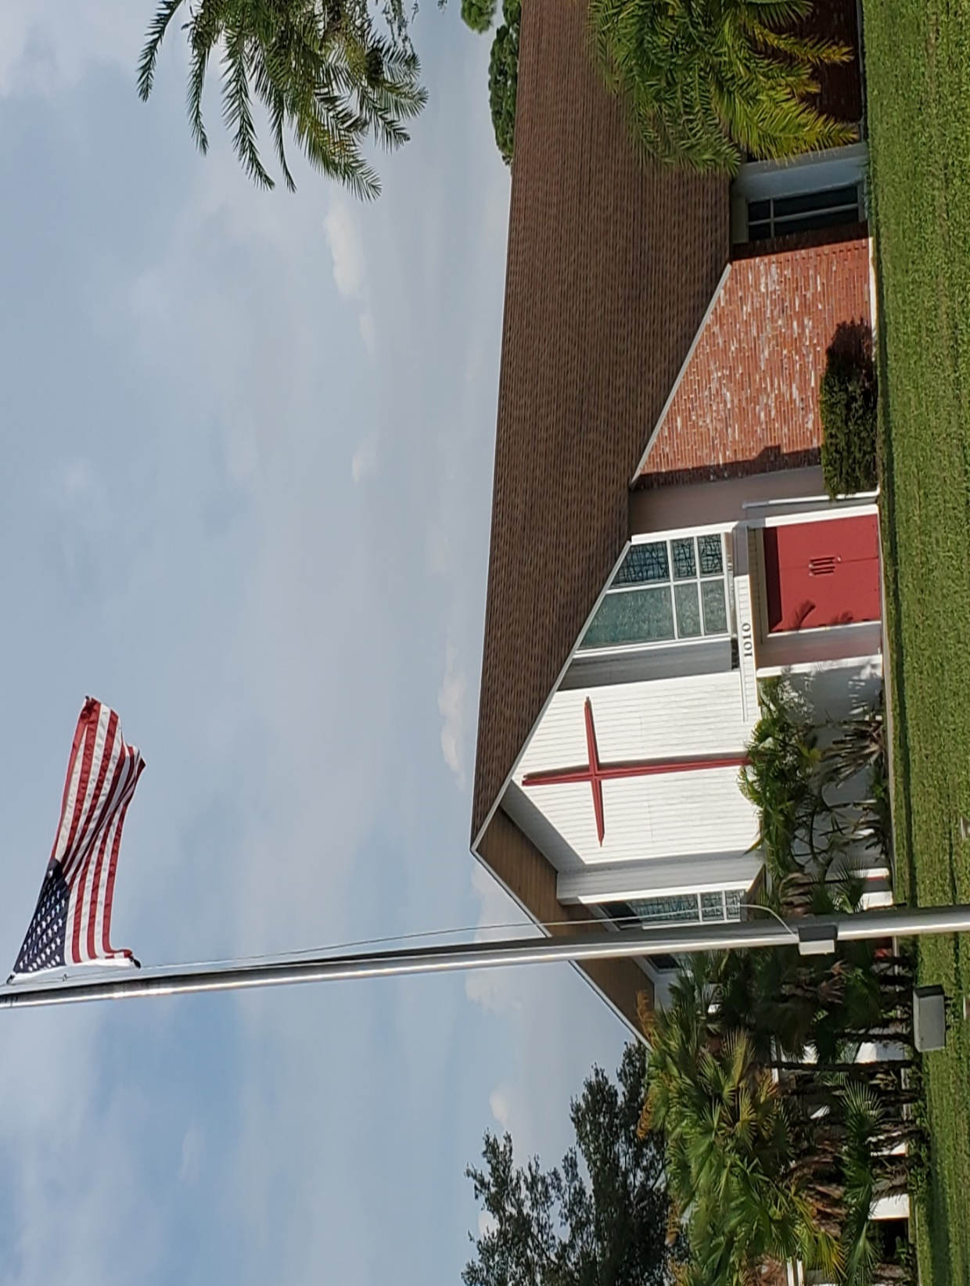

**St. Mary’s Episcopal Church**

1010 24th Avenue West, Palmetto, FL 34221

941-722-5292

Email – [stmaryspalmetto@verizon.net](mailto:stmaryspalmetto@verizon.net)

Website – stmaryspalmetto.com

**Pentecost 10**

**July 28, 2024**

**PARISH STAFF**

**The Rev. Glen Graczyk, Rector** [frgleng@gmail.com](mailto:frgleng@gmail.com) (727) 432-4014

**The Rev. William de la Torre, Hispanic Ministry (**813) 802-8617

**Rev. Cheri Ford, Assisting Priest** (941) 981-3195)

**Music Minister: Joyce Ives** (603) 236-1939

**Admin. Asst. Elisa Hughes** [stmaryspalmetto@verizon.net](mailto:stmaryspalmetto@verizon.net) (813) 394-0032

**ST. MARY’S VESTRY**

**Senior Warden – Frank Grondahl** [ffgskg@msn.com](mailto:ffgskg@msn.com) **(**941) 900-1009

**Junior Warden** **– Bill Cooley** [dcool12839@gmail.com](mailto:dcool12839@gmail.com) (518) 796-2352, (518) 791-2774

**Treasurer**- **Lorraine Wood** [ljhwood53@gmail.com](mailto:ljhwood53@gmail.com) (941) 447-3570

**Beverly Hunt** [Huntb104@gmail.com](mailto:Huntb104@gmail.com) (941) 228-1888

**Nancy Valenti** [nancyval@hotmail.com](mailto:nancyval@hotmail.com) (941) 729-1824

**Peggy Brogan** [pegbrogan48@gmail.com](mailto:pegbrogan48@gmail.com) **(**941) 744-6429

**Lynda Priepot** [lyndajpriepot@yahoo.com](mailto:lyndajpriepot@yahoo.com) (941) 504-2505

All music printed in bulletin is under One License.net

**10:00 – Prelude: Canon in D…**Pachelbel

**10:00 Call to Worship: *Seek ye first*** . . . #711 vs. 1 & 2

**10:00 – Processional Hymn: We will extoll, ever blessed Lord -** #404

**Greeting:**

**C:** Blessed be God: Father, Son, and Holy Spirit.

**P:** And blessed be his reign, now and forever. Amen

**Hymn of Praise:** ***The Gloria***

**7:45 -**– Page 356 **BCP**

**10:00** - #421

**Collect of the day: Proper 12**

O God, the protector of all who trust in you, without whom nothing is strong, nothing is holy: Increase and multiply upon us your mercy; that, with you as our ruler and guide, we may so pass through things temporal, that we lose not the things eternal; through Jesus Christ our Lord, who lives and reigns with you and the Holy Spirit, one God, for ever and ever.

**P**: Amen

**The Lessons**

*Sit*

**First Reading**: **2 Kings 4:42 - 44**

**R:** The Word of the Lord.

***P:***  *Thanks be to God.*

**Psalm Response:** ***Psalm 145:10-19***

|  |
| --- |
| All your works praise you, O LORD, *     and your faithful servants bless you. |
| They make known the glory of your kingdom *     and speak of your power; |
| That the peoples may know of your power *     and the glorious splendor of your kingdom. |
| Your kingdom is an everlasting kingdom; *     your dominion endures throughout all ages. |
| The LORD is faithful in all his words *     and merciful in all his deeds. |
| The LORD upholds all those who fall; *     he lifts up those who are bowed down. |
| The eyes of all wait upon you, O LORD, *     and you give them their food in due season. |
| You open wide your hand *     and satisfy the needs of every living creature. |
| The LORD is righteous in all his ways *     and loving in all his works. |
| The LORD is near to those who call upon him, *     to all who call upon him faithfully. |

**Second Reading: *Ephesians 3:14-21***

**R:** The Word of the Lord.

***P:*** *Thanks be to God.*

*Stand*

**10:00 - Gospel Hymn: *O love, how deep, how broad, how high*** - #448, vs. 1,2 & 3

**C:**  My sisters and brothers a reading from the Holy Gospel of our Lord Jesus Christ according to Mark.

***P:***  *Glory to you, Lord Christ*

**Gospel: *John 6:1-21***

**C**: The Gospel of the Lord.

***P:*** *Praise to you Lord, Christ.*

**10:00 - Gospel Hymn:** #448 vs, 4,5 & 6

*Sit*

***Homily****:*

*Stand*

**Profession of Faith:*****Nicene Creed*** – Page 358 **BCP**

**Prayers of the People:** Please respond: Bread of Life, hear our prayer.

**Peace**

*Sit*

**Announcements:**

**Offertory Sentence:** Walk in love, as Christ loved us and gave himself for us, an  
offering and sacrifice to God.  Ephesians 5:2

**Offertory Hymn: All who hunger gather gladly –** Yellow music insert

**THE GREAT THANKSGIVING**

*Stand*

**Preface of the Lord’s Day**

**Sanctus: 7:45 *–*** P. 363 ***– BCP***

**10:00 *–*** **Sanctus - S125**

**Eucharistic Prayer B**

**Memorial Acclamation**

**Great Amen**

**The Lord’s Prayer:***Our Father . . .*

**Breaking of the Bread:**

**C:** Alleluia!Christ our Passover is sacrificed for us;  
***P:****Therefore, let us keep the feast. Alleluia!*

**Prayer for a Spiritual Communion:**

My Jesus, I believe that you are truly present in the Blessed Sacrament of the Altar. I love you above all things, and long for you in my soul. Since I cannot receive you in the Sacrament of your Body and Blood, come spiritually into my heart. Cleanse and strengthen me with your grace, Lord Jesus, and let me never be separated from you. May I live in you, and you in me, in this life and in the life to come. Amen.

**Communion Hymn: Break thou the bread of life –** Buff Music insert

*Stand*

**Prayer after Communion:** Page 365 ***BCP***

**Blessing:**

**Recessional Hymn:  *God, my King, thy might confessing*** - #414

**Dismissal:**

**Prayer of Healing and Wellness:**

***Parishioners:***The Bustle’s, Kathryn Stevenson, Karen Moore, Priscilla Martin, Marilyn Wolter, Jodey Porter, Bill Gill, Bill Speer, Louise Silvanic, Lynda Priepot, Steve Ives, Barbara Renney, Mary Jane Daggett, Ora Mae James and Fr. Glen.

***Family and Friends:*** Brand Ramsey (family friend of The Reynolds), Charlotte (daughter of Holly Quillian), Robert Johnson (son of Lynda Priepot), Betsy Ramsey and Mary and Jack Hertenstein (friends of The Reynolds), Dick Stagner (brother in law of Louise Silvanic), Steve Gillespie (nephew of Gail Cascella), Nicola Moxey (daughter of Christine Pratley), Taryon Degon (granddaughter of Jan Ciancarelli), Carol Johnson’s sister, Christine Booth (Fr. Glen’s sister), Karen Perdue (Gail Cascella’s niece), Kevin-Ford family (family of The Ford’s), Paul Ciancarelli (Jan’s son), Art Sounia (friend of Doreen Colket) and Juliet Clarke (granddaughter of Pratley’s), Joe Fairchild (friend of the Cooley’s), Melanie Moran (friend of Christine) and Emily Ann Norris (family of Linney Reynolds), Marge Schrauth (friend of Fr. Glen), Dan Bryan (brother-in-law of Bob Cabnet), Maxwell Kappel (grandson of The Martin’s), Maxon McNeil (friend of the Shorts), Jayme and Jeremy (family of Cooley’s), and Kathy Harlow (sister of Doreen Colket), John Heath (friend of Jane Bryant), Steven Grondahl (son of Sandy and Frank Grondahl), Ron Bernot (Neighbor of Dinny Sayre), Jordan Skeard (nephew of Alice and George Short), Rev. Jane Allen (Short’s priest in Newfoundland), Leo Johnson (friend of Alice and George Short), George Silvanic (Louise’s grandson), Wally Skeard (brother in law to George & Alice Short), Wally Skeard’s (sister of Blanche Stewart), Elisa Hughes, Hunter Hughes (son of Elisa) and Liz Brown (mother of Elisa Hughes), Dr. Greg Gutowski (Priscilla Martin), Steve Harlow (brother-in-law of Doreen Colket), Charles (friend of Mindel De La Torre).

***Prayers for Safety and Service****:*

Ben Richardson (son of Christine Pratley), Alexander Moxey (grandson of Christine), Christine Dorr (daughter of Jane Bryant), George Phillip Silvanic (Louise Silvanic’s grandson), Jody Cooley (son of Bill and Donna Cooley), and Logan Valenti (grandson of Nancy Valenti).

***July/August 2024***

|  |  |  |  |  |  |  |
| --- | --- | --- | --- | --- | --- | --- |
| **28** | **29** | **30** | **31** | **1** | **2** | **3**  **The Cooley’s**  Sacrament of Marriage - Saint John XXIII Roman Catholic Church ... |
| **4**  **Love Offering**    **Potluck** |  | **6**  **Trudy Lovejoy** | **7** | **8** | **9** | **10** |